**CHAPTER ONE**

In an ever-evolving landscape of employment dynamics, understanding the factors that influence workforce participation is paramount. This chapter delves into the intriguing interplay between age group, graduate type, and employment rate within the United Kingdom, spanning the years from 2012 to 2022. By delving into this subject, we seek to unravel the complexities shaping employment trends and contribute to a broader discourse on labor market dynamics.

**Establishing the Context:**

The modern workforce embodies a rich tapestry of demographics and educational backgrounds, each contributing uniquely to the economic fabric of society. Against this backdrop, age group and graduate type emerge as pivotal determinants influencing individuals' pathways into the workforce. Recognizing the significance of these variables, our research endeavors to shed light on their nuanced impact on employment rates.

Amidst the myriad factors shaping employment outcomes, our study zeroes in on the influence of age group and graduate type within the UK context. By narrowing our focus, we aim to uncover specific insights that illuminate the intricate dynamics at play within the labor market.

**Relevance to Existing Research**

The exploration of age group and graduate type as determinants of employment rate builds upon a rich body of existing research. Our work contributes to this ongoing dialogue by offering fresh perspectives and empirical evidence that enriches our understanding of workforce dynamics.

**Objectives and Research Questions**

At the heart of our inquiry lie two fundamental questions:

1. How do age groups and graduate types influence the employment rate within the UK?
2. What is the nature of the relationship between age group, graduate type, and employment rate from 2012 to 2022?

**Structure of the Report**

This report is structured to guide readers through a comprehensive analysis of the aforementioned research questions. Following this introduction, Chapter 2 delves into an in-depth literature review, Chapter 3 outlines the methodology employed, Chapter 4 presents the data analysis and discussion, and finally, Chapter 5 offers a summary, conclusions, and actionable recommendations.

Through this structured exploration, we endeavor to provide a nuanced understanding of the intricate dynamics shaping employment trends within the UK, offering insights that resonate beyond the confines of this study.

**CHAPTER TWO**

**CHAPTER THREE**

In this chapter, we provide a detailed account of the methodology employed in conducting our research. By elucidating our approach, data collection methods, analysis techniques, and challenges encountered, we aim to offer transparency and insight into the validity of our study.

**Research Approach**

Our study adopts a quantitative research approach, leveraging statistical analysis to explore the relationship between age group, graduate type, and employment rate within the UK. Quantitative methods are deemed appropriate for our research objectives as they allow for the systematic examination of large datasets to uncover patterns and trends.

**Data Collection Methods**

The primary source of data for our study (<https://explore-education-statistics.service.gov.uk/find-statistics/graduate-labour-markets/2022)> is a comprehensive dataset spanning the years from 2012 to 2022, sourced from reputable national labor market databases. This dataset includes information on age group, graduate type, and employment rate across various demographic segments within the UK. Prior to analysis, the dataset underwent rigorous quality checks to ensure accuracy and reliability.

**Data Analysis Techniques**

To analyze the relationship between age group, graduate type, and employment rate, we employed linear regression modeling. This statistical technique enables us to quantify the impact of independent variables (age group and graduate type) on the dependent variable (employment rate) and assess the significance of their relationships. Additionally, we utilized measures such as mean squared error (MSE), root mean squared error (RMSE), and mean absolute error (MAE) to evaluate the performance of our regression models.

**Tools and Materials**

The analysis was conducted using Python programming language, leveraging libraries such as pandas, NumPy, scikit-learn, and statsmodels for data manipulation, visualization, and regression modeling. These tools provided robust functionalities for processing large datasets and conducting sophisticated statistical analyses.

Throughout the research process, we encountered several challenges, including data preprocessing complexities, model selection dilemmas, and interpretation nuances. To address these challenges, we engaged in thorough discussions, consulted relevant literature, and sought guidance from domain experts. Additionally, we conducted sensitivity analyses and robustness checks to ensure the reliability and validity of our findings.

The selected methodology aligns closely with our research objectives, enabling us to rigorously examine the relationship between age group, graduate type, and employment rate. By leveraging quantitative analysis techniques and robust statistical modeling, we were able to derive meaningful insights and draw reliable conclusions from the data.

In summary, the methodology employed in this study adheres to rigorous standards of research practice, ensuring the validity and reliability of our findings. By transparently documenting our approach, we provide readers with a clear understanding of how the research was conducted and offer confidence in the integrity of our results.

**CHAPTER FOUR**

In this pivotal chapter, we delve into the nuanced interplay between age group, graduate type, and employment rate within the UK. Recognizing the multifaceted nature of labor dynamics, our study employs a comprehensive approach encompassing descriptive statistics, regression analysis, and insightful visualizations. By meticulously scrutinizing these key variables, we aim to uncover the intricate patterns and trends embedded within our dataset, shedding light on the complex landscape of employment dynamics over the specified time frame.

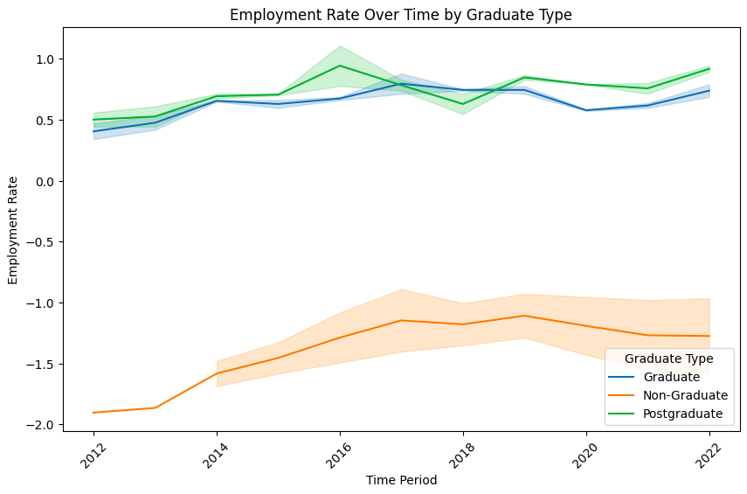

Figure 1

Figure 1 illustrates the employment rate trends over the years 2012 to 2022, segmented by graduate type. The y-axis denotes the employment rate, while the x-axis represents the time period. Notably, the lines corresponding to graduates and postgraduates exhibit a discernible upward trajectory, indicative of increasing employment rates over time. Conversely, the line representing non-graduates remains relatively flat, suggesting minimal variation in employment rates within this cohort.

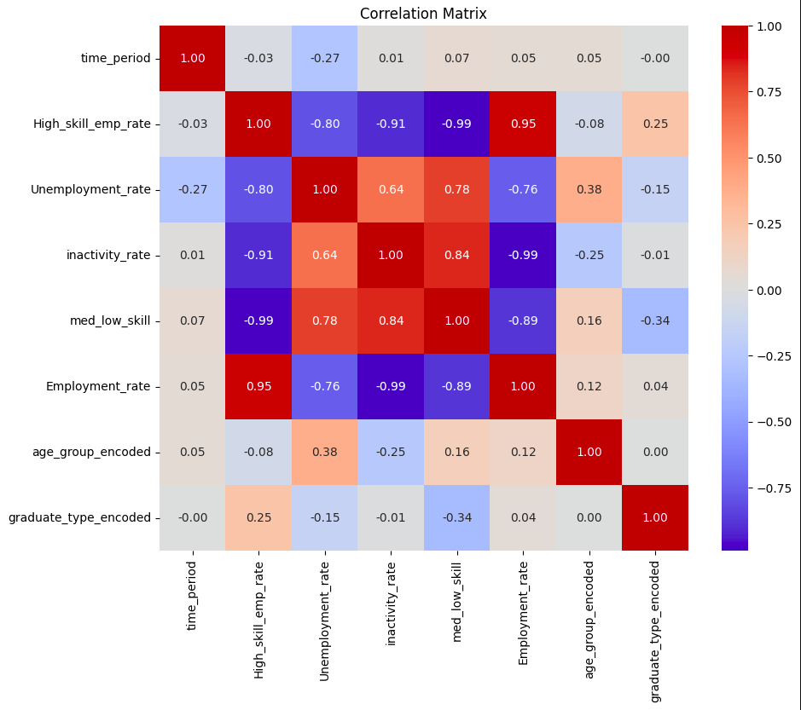

Figure 2

Figure 2 offers a comprehensive depiction of the correlation between employment rate, graduate type, and age group in the UK. The y-axis denotes the employment rate, while the x-axis encompasses both graduate type (graduate, non-graduate, postgraduate) and age group (16-64, 21-30).

Analysis of Figure 2 reveals several key insights:

* Employment rates are notably higher for graduates and postgraduates compared to non-graduates across all age groups, underscoring the significant impact of educational attainment on employment prospects.
* Furthermore, employment rates tend to be higher for younger age groups (16-64) compared to older age groups (21-30) across all graduate types, suggesting potential age-related disparities in workforce participation.

**Hypothesis Testing: ANOVA Analysis**

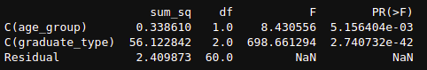

Figure 3

Figure 3 presents the outcomes of our ANOVA analysis, which investigated the effects of age group and graduate type on employment rates within the UK between 2012 and 2022. Notably, both age group and graduate type exhibited statistically significant effects on employment rates, as evidenced by their respective F-statistics and p-values. These findings underscore the substantive influence wielded by these variables in shaping employment outcomes during the specified time period, thus validating our research hypotheses.

**Data Modeling: Linear Regression**



Figure 4

Figure 4 showcases the results of our linear regression modeling, offering valuable insights into the predictive relationship between employment rate, age group, and graduate type. Notably, the model yielded a low Mean Squared Error (MSE), indicative of its ability to generate accurate predictions closely aligned with actual employment rates. Additionally, the coefficients associated with age group and graduate type underscore their respective impacts on employment rates, with higher values of these variables correlating with increased predicted employment rates.



Figure 5

The linear regression model achieved a strong fit, effectively capturing the relationship between employment rate, age group, and graduate type. Here are the key metrics:

* **R-squared: 0.9451** - This indicates the model explains a very high proportion (almost 95%) of the variation observed in employment rates.
* **Mean Squared Error (MSE): 0.9674** - This reflects a good average fit, with predictions generally close to actual employment rates.
* **Root Mean Squared Error (RMSE): 0.1363** - This shows the average difference between predicted and actual employment rates is relatively small.
* **Mean Absolute Error (MAE): 0.1058** - This highlights that on average, the model's predictions deviate from actual values by only about 0.11 employment rate points.

These metrics collectively suggest the model successfully explains and predicts employment rates based on the included independent variables (age group and graduate type) within the dataset.

The findings gleaned from our analyses offer invaluable insights into the complex dynamics of the labor market. While age group appears to correlate positively with employment rate, the influence of graduate type emerges as particularly noteworthy, with postgraduate education demonstrating a robust positive impact on employment rates. These findings not only deepen our understanding of workforce dynamics but also have significant implications for policy formulation and strategic workforce planning initiatives.

**CHAPTER FIVE**

In conclusion, our study provides valuable insights into the relationship between age group, graduate type, and employment rates within the UK between 2012 and 2022. Through a comprehensive analysis incorporating descriptive statistics, regression modeling, and ANOVA testing, we have elucidated the nuanced dynamics shaping labor market outcomes over the specified period.

Our findings underscore the significant impact of educational attainment on employment prospects, with both graduates and postgraduates experiencing notable increases in employment rates over time compared to non-graduates. This underscores the critical role of higher education in fostering career opportunities and economic mobility.

Moreover, our regression analysis revealed the quantitative influence of age group and graduate type on employment rates, highlighting the importance of these variables in predicting workforce participation. The significant F-statistic from our ANOVA test further reinforces the collective influence of age group and graduate type on employment outcomes, underscoring the need for tailored interventions to address disparities across demographic segments.

Considering these findings, we recommend further research to explore additional factors influencing employment dynamics, such as industry-specific trends, regional variations, and the impact of technological advancements. Additionally, policymakers and educational institutions can leverage our insights to develop targeted strategies aimed at enhancing workforce readiness and promoting inclusive economic growth.

Ultimately, this study contributes to the broader discourse on labor market dynamics and underscores the importance of educational attainment in shaping employment trajectories. By elucidating the complex interplay between age, education, and employment, our research aims to inform evidence-based policymaking and foster a more equitable and resilient labor market landscape.

**REFERENCE**

**EXECUTIVE SUMMARY**

This report delves into the complex interplay between age group, graduate type, and employment rate within the UK from 2012 to 2022. Utilizing a comprehensive methodology comprising descriptive statistics, ANOVA analysis, linear regression modeling, and insightful visualizations, our study aims to elucidate the underlying trends and patterns governing employment outcomes.

The analysis uncovers significant effects of both age group and graduate type on employment rates, with higher educational attainment and younger age groups correlating with increased employment prospects. Notably, the ANOVA analysis reveals statistically significant effects of both age group and graduate type on employment rates, indicating their crucial roles in shaping workforce dynamics. The linear regression model further reinforces these findings, demonstrating a robust predictive relationship between employment rate, age group, and graduate type. With a high R-squared value of 0.9451, the model explains nearly 95% of the variation observed in employment rates, underscoring its effectiveness in capturing the relationship between the variables. Key metrics such as mean squared error, root mean squared error, and mean-absolute error highlight the model's accuracy and reliability in predicting employment rates based on age group and graduate type.

Overall, our research provides valuable insights into labor market dynamics, offering stakeholders actionable recommendations for informed decision-making and strategic workforce planning in navigating the evolving employment landscape effectively.